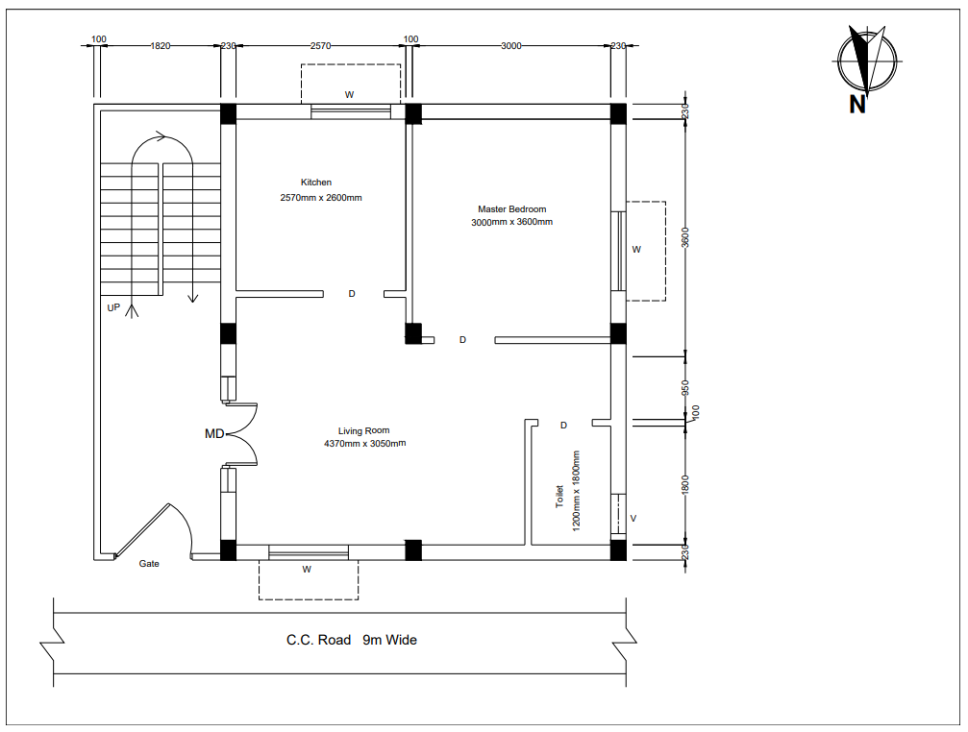
Figure 2.3: ground floor plan.

